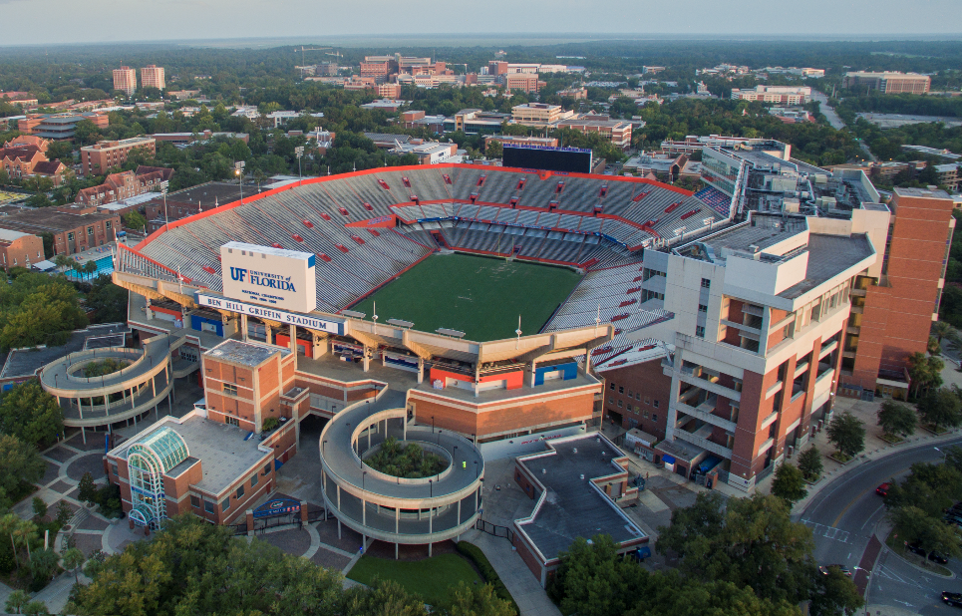

**Ben Hill Griffin Stadium**

1. The stadium seats 88,548 people who come to view the football games that occur on the field. The stadium acts as a modern day Coliseum, which was also made out of concrete.
2. The stadium is built out of concrete, from the foundation to the steps that house the seats.
3. Football is a favorite American pastime and having a football team really raises our school’s morale; everyone comes together to cheer for the Gators and it gives us a sense of community and raises school spirit. We feel proud to be attending the school when our team is doing well.
4. Concrete makes it so such a large structure could be constructed easily and cheaply. Bricks didn’t have to be transported from a quarry somewhere and erected on site, all they had to do was transport cement, which is easy to do since it is a liquid.
5. I would change it so that it has memory alloy and self-repairing concrete in it. This would make it so maintenance doesn’t have to be done as often on the structure. This wouldn’t really affect its current social function and symbolism, just make it easier to upkeep. This would make it slightly more expensive, but also make it so maintenance doesn’t need to be performed as often, and it’s better if a stadium that seats 88 thousand people was more durable.